Unit 4 - Introduction to Computer Network Architecture
Computer network architecture refers to the design framework that defines the structure, organization, and communication protocols of a network. It determines how data is transmitted, received, and managed across a network. Network architecture includes hardware components, software protocols, and network topologies to enable efficient communication.
Types of Network Architecture
- Client Server Architecture
- Peer-Peer Network Architecture
Client Server Architecture
Client-server architecture is a network model where multiple clients (users or devices) communicate with a central server to access data, applications, or services. The server is a powerful computer that manages resources, processes client requests, and ensures data security, while the clients are devices such as computers, smartphones, or tablets that request services from the server. This architecture enhances efficiency, scalability, and centralized control, making it ideal for web applications, email systems, and database management.
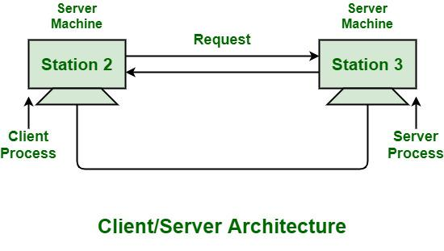
Advantages
- Centralized Management – Servers manage data, security, and network resources efficiently.
- Scalability – More clients can be added without significantly affecting performance.
- Data Security – Centralized storage ensures better control and protection of sensitive data.
- Efficient Resource Utilization – Servers handle processing tasks, reducing the burden on client devices.
- Backup and Recovery – Data can be regularly backed up on the server, ensuring minimal data loss.
Disadvantages
- Single Point of Failure – If the server crashes, clients lose access to resources.
- High Cost – Setting up and maintaining servers can be expensive.
- Network Congestion – Heavy client requests may slow down the server.
- Dependency on Server – Clients rely on the server for processing and access to resources.
- Security Risks – If a server is compromised, all connected clients may be affected.
Use Cases
- Web Applications – Websites like Google, Facebook, and Amazon use client-server models to serve millions of users.
- Email Services – Gmail and Outlook rely on centralized mail servers to send and receive emails.
- Online Banking – Banks use client-server architecture to handle secure transactions.
- Cloud Computing – Platforms like AWS and Google Cloud provide computing and storage services to clients.
- Enterprise Systems – Large organizations use client-server architecture for database management and internal applications.

Peer to Peer Network Architecture
Peer-to-peer (P2P) architecture is a decentralized network model where each device, known as a peer, acts as both a client and a server, sharing resources directly with other peers without relying on a central server. This model enhances scalability, as new peers can join and contribute computing power and storage. P2P networks are highly resilient because there is no single point of failure, making them ideal for applications such as file sharing, blockchain, and distributed computing. However, P2P networks can face challenges, such as security risks, since data is distributed among multiple peers, and performance issues may arise if some peers have low bandwidth or go offline. Despite these challenges, P2P remains a powerful architecture for decentralized applications like BitTorrent, Bitcoin, and Skype, where direct communication between users is essential.
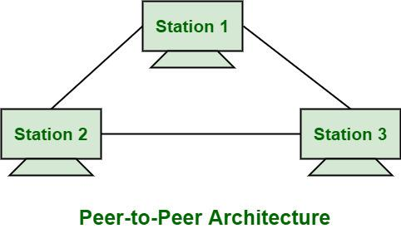
Advantages
- Decentralization – No central server, reducing dependency on a single point of failure.
- Scalability – New peers can join easily without the need for server upgrades.
- Cost-Effective – No need for expensive servers or centralized management.
- Efficient Resource Utilization – Peers share processing power, bandwidth, and storage.
- Resilience – The network remains functional even if some peers disconnect.
Disadvantages
- Security Risks – Data is shared directly among peers, increasing vulnerability to malware and hacking.
- Data Inconsistency – No centralized control can lead to outdated or inconsistent data.
- Performance Issues – Speed and reliability depend on peer availability and network bandwidth.
- Difficult Management – Monitoring and regulating the network is challenging due to its distributed nature.
- Limited Searchability – Finding specific resources or data in large P2P networks can be inefficient.
Use Case
- File Sharing – Platforms like BitTorrent allow users to share large files without a central server.
- Blockchain & Cryptocurrencies – Bitcoin and Ethereum use P2P networks for decentralized transactions.
- VoIP Services – Skype originally used P2P for voice and video communication.
- Distributed Computing – Projects like SETI@home use P2P to distribute computational tasks.
- Online Gaming – Some multiplayer games use P2P connections for real-time interactions between players.
Centralized Network
A centralized network is a system where all devices (clients) connect to a central server that manages data, controls communication, and provides resources. This model ensures efficient management, security, and consistency, as all data is stored and processed at a single point. However, it also creates a single point of failure—if the central server crashes, the entire network can become inaccessible. Centralized networks are commonly used in banking systems, cloud services, and corporate networks.
Decentralized Network
A decentralized network distributes control among multiple nodes, reducing dependency on a single server. Each node can act as both a client and a server, making the network more resilient, scalable, and fault-tolerant. However, decentralization can lead to data inconsistency, security risks, and complex management. This model is widely used in blockchain, peer-to-peer (P2P) file sharing, and distributed computing systems. While centralized networks offer better control and security, decentralized networks provide greater redundancy and independence.
Both centralized and decentralized networks have their own strengths and weaknesses. Centralized networks offer better control, security, and efficiency but are vulnerable to single points of failure. On the other hand, decentralized networks provide resilience, scalability, and independence but can face security risks and management challenges. The choice between the two depends on the specific needs of the system, with centralized models being ideal for structured environments like banking, while decentralized networks are preferred for peer-to-peer applications like blockchain and file sharing.

